**Draw a diagram of the 1-bit ALU enhanced with overflow detection.**

ALU operation means performing 1 bit logical operation or 1-bit arithmetic operation.Logical operation includes performing bit wise AND, bitwise OR etc and arithmetic operation includes performing addition ,subtraction etc.

Here 1-bit ALU means all inputs for operation are 1-bit.

The 1-bit logical unit for AND and OR looks like Figure 1. The multiplexor on the right then selects a AND b or a OR b, depending on whether the value of Operation is 0 or 1.

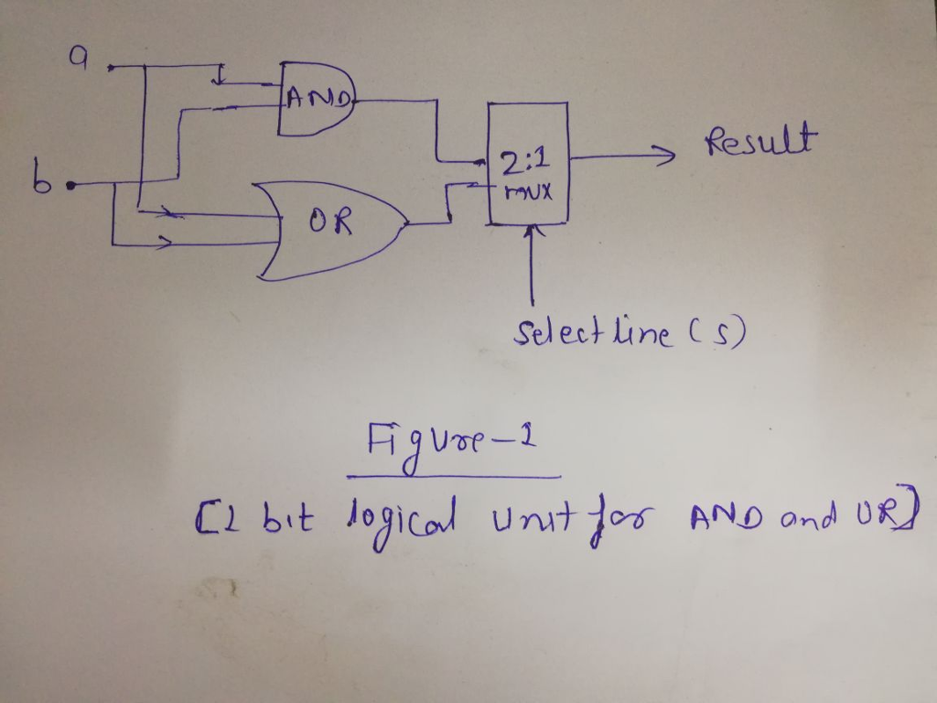

The next function to include is addition. An adder must have two inputs for the operands and a single-bit output for the sum. There must be a second output to pass on the carry, called CarryOut.Since the CarryOut from the neighbor adder must be included as an input, we need a third input. This input is called CarryIn.

**Overflow:**

Overflow occurs when there are insufficient bits in a binary number representation to portray the result of an arithmetic operation. Overflow occurs because computer arithmetic is not closed with respect to addition, subtraction, multiplication, or division. Overflow *cannot* occur in addition (subtraction), if the operands have different (resp. identical) signs.

**A Simpler Formula for Overflow:**

V = ck-1 XOR ck-2

if V=1 then there is overflow else not.